**Sprint 2 Plan**

**Product Name:** SummarAIze

**Sprint Completion Date:** May 6, 2025

**Revision Number:** V1.1

**Revision Date:** April 23th, 2025

**Scrum Meeting Times:** M - 9:15-9:30pm, W - 12:00-2pm, F - 9:30am - 10:30am (Meeting with TA)

**High-Level Goal:** Complete the overall basic set-up for the project, finalize main goals, and delegate tasks.

**Task Listing:**

* {3} User story 2.1 [13]
  + **As an educator, I want to be able to create a visual representation so that I can make presentations so that complex concepts are simplified for students.**
    - Task 1: Extract visuals from research papers (2 hr)
    - Task 2: Research and add API to generate images (2 hr)
    - Task 3: Research and use Python libraries to string together images (3 hr)
    - Task 4: Add animation over visuals (4 hr)
* {4} User story 2.2 [8]
  + **As a student, I need to be able to play the narrated voiceover so that I can simultaneously absorb information while completing other tasks at hand.**
    - Task 1: Research and add API to generate narrated voice over of summary (2 hr)
    - Task 2: Connect it to frontend (2 hrs)
* {5} User story 2.3 [3]
  + **As a student, I should have a user account that stores my information so that I can track my progress.**
    - Task 1: Set up database (Firebase) for authentication (1 hr)
    - Task 2: Connect Firebase to backend (2 hr)
    - Task 3: Add authentication to frontend and connect to backend (2 hr)
* {11} User Story 2.4 [3]
  + **As a student, I want to choose the summary length (short, medium, detailed) so that I get the right level of depth for my needs.**
    - Task 1: Display summary in frontend (1 hr)
    - Task 2: Incorporate user input for summary length on frontend (1 hr)
    - Task 3: Incorporate user input from frontend to change feature prompt in backend (1 hr)

**Team Roles:**

Koena: Project Owner, Developer

Ashton: Scrum Master, Developer

Poojitha: Developer

Amisha: Developer

Nathan: Developer

**Scrum Board:**

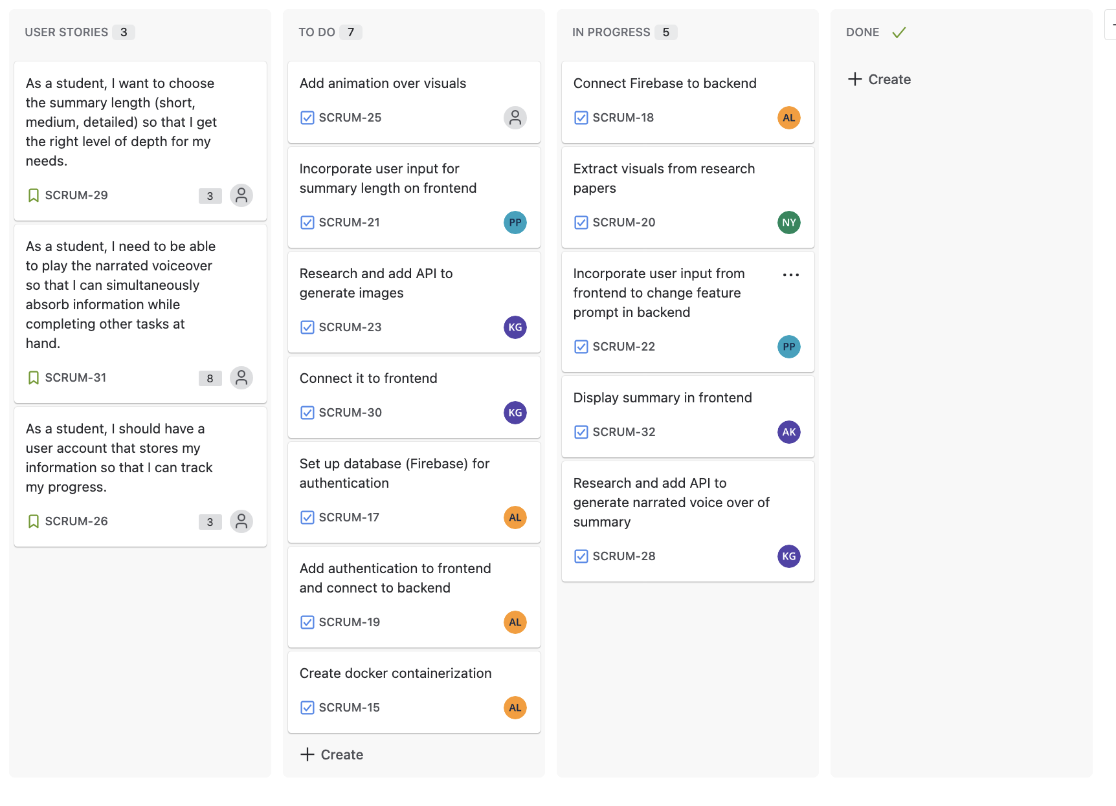

**Burn-up Chart:**

